DEVELOP A WEB APPLICATION USING NODE-RED
Team ID | Abiyavincy D, Berlin K, Jemilda J, Kerin Shinu VS
Project Name | Project-Real-time River  Water Quality Monitoring and Control System
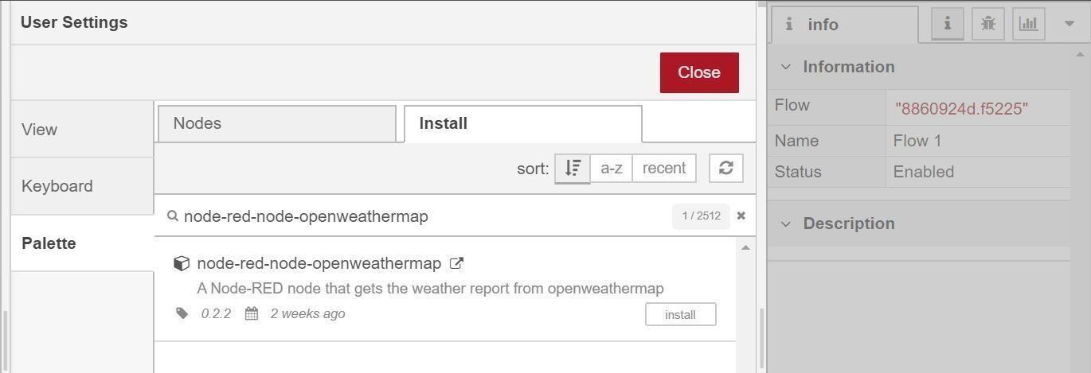

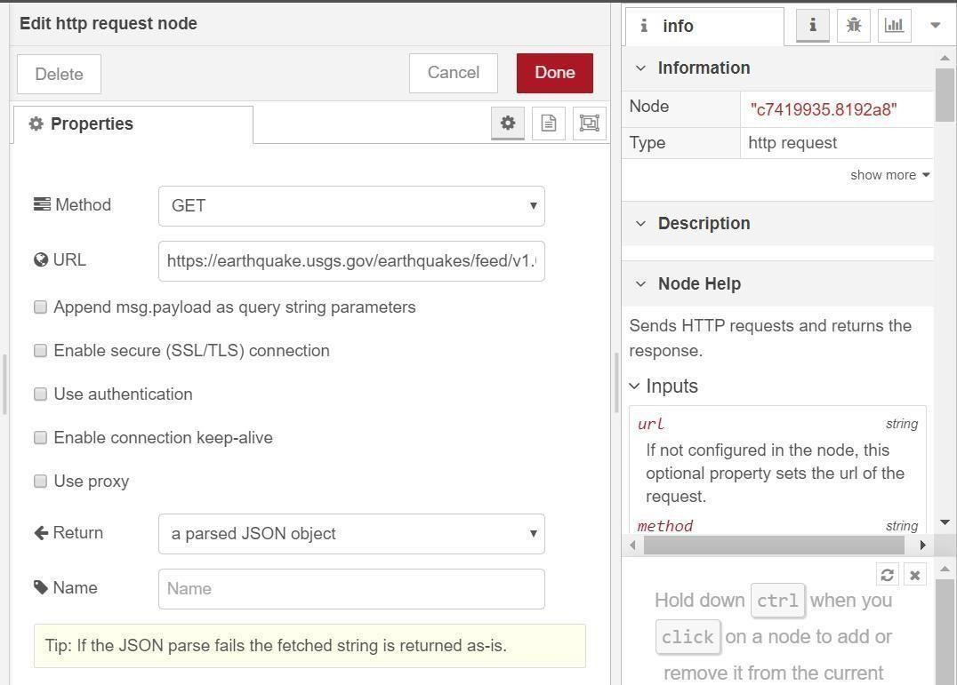

Add a change node. Double-click the node to modify it. Name this node Set Earthquake Info. In
the Rules section, addes
rul to Delete msg.topic,
msg.headers, msg.statusCode, msg.responseUrl and
msg.redirectLis
t and
Setd payload.features.
msg.payloa
{
"type":properties.type, "magnitude": properties.mag, "location": properties.place,
"longitude":geometry.coordinates[0], "latitude":geometry.coordinates[1], "depth":geometry.coordinates[2], "timestamp": $fromMillis( properties.time,

